Introduction:
Learning Visual Basic (VB) will be very useful for any computer user ages ranging from 12 to anything really!
What the word ‘Basic’ stands for is, 'Beginner's All-purpose Symbolic Instruction Code'. The reason why the word ‘Visual’ is in front of it is because unlike most programming languages where you would normally have to type coding in to create a command button or a text box, Visual Basic is basically just a "click and drag" method.

You can buy your very own version of Visual Basic 6 from any good computer software store for around £ (research prices).
The minimum system requirements needed to run Visual Basic are as followed:
- A CD-ROM drive;
- More than 24mb of RAM;
- More than 48mb of free hard disk space.
Following the Visual Basic installation process is pretty simple but if you encounter any problems, like most people do, then please feel free to e-mail me at, jamesjd9@hotmail.com.

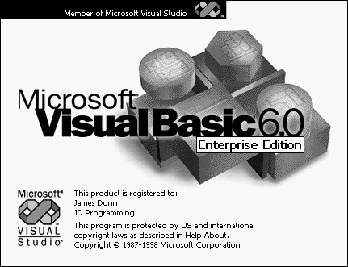

First Steps:
When you load Visual Basic a pop-up window should appear asking what project you would like to create. Selecting ‘Standard EXE’ is the best choice for the time being.

When the project loads you should see a window saying, “Project1 - Form1 (Form)”. This is what we call a Form. To the left of the form is a window which we call the Tool-Box. To the right is the Properties window and above the Properties window is a Project window.
The windows you see should be similar to these.
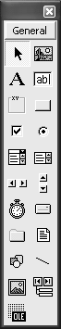 | 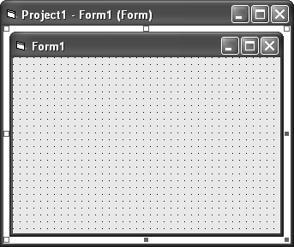 | 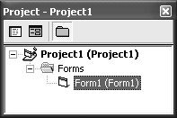  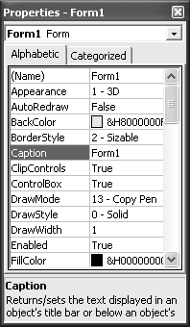

Now I will explain some of the controls you can use in your Projects to start and build-up your very own applications.

Command Buttons: Command Buttons is very user because it places the user in control of the program so they can tell it what to do.
To insert a Command Button you’ll have to click on the icon and click and drag where you want it to be positioned and then just release the mouse when you are happy with its positioning. You can change the Command Buttons caption by selecting, “Caption” in the Properties and then changing it to suit your needs.
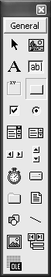 | 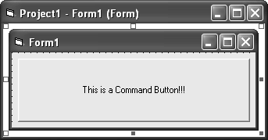

Labels: Labels are used to display text which can’t be edited. For example it might inform the user about something.
To insert a Label you’ll have to click on the icon and click and drag where you want it to be positioned and then just release the mouse when you are happy with its positioning. You can change the Labels caption by selecting, “Caption” in the Properties and then changing it to suit your needs.
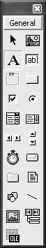 | 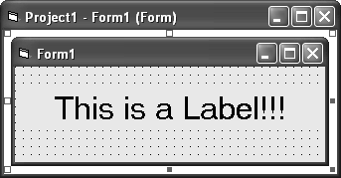

Text Boxes: Text boxes are used to display text and edit text during runtime. They can store large amounts of data which can be very useful.
To insert a Text Box you’ll have to click on the icon and click and drag where you want it to be positioned and then just release the mouse when you are happy with its positioning. You can change the Text Boxes text by selecting, “Text” in the Properties and then changing it to suit your needs.
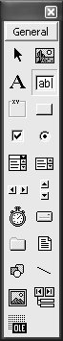 | 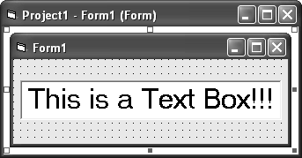

Picture Boxes: Picture boxes can contain images and you can also draw pictures into one.
To insert a Picture Box you’ll have to click on the icon and click and drag where you want it to be positioned and then just release the mouse when you are happy with its positioning. You can change the Pictures Boxes image by selecting, “Picture” in the Properties and then search for the image which you choose to use.
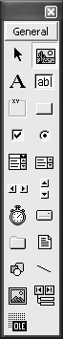 | 